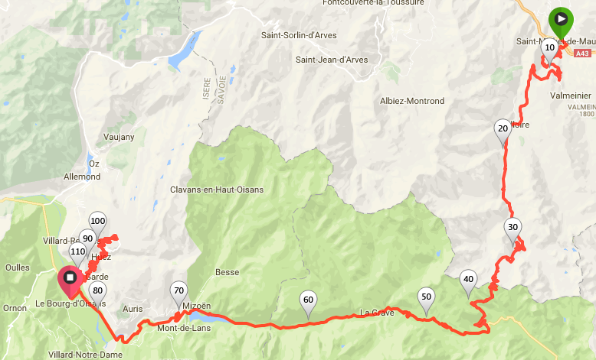
Distance: 112 km
Elevation: 3,250 m
ETA: 4 to 7 hours
⬅
⬅
⬅
⬅
⬅
⬅
⬅
⬅
⬅
⬅
⬅
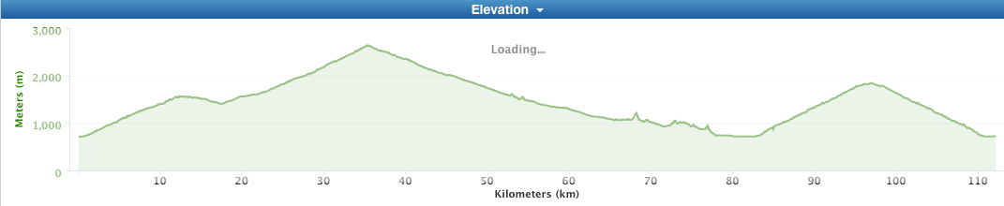
LINK TO GARMIN FILE

* Distances are approximate and can be off by a few kilometers. Watch for road signs.

KM | KM TO  NEXT | TURN | ROAD AND COMMENTS
0 | 0.5 | L | Turn left out of the parking lot on to Rue General Ferrie = D1006
0.5 | 12 | R | D902 = Rue de Galibier  Col du Telegraph begins. 12.1 km, 7% average, 832 m gain
12.5 | 4.8 | - | Top of the Telegraph. There is a café at the top.

KM | KM TO  NEXT | TURN | ROAD AND COMMENTS
17.3 | 0.2 | 1st exit | Stay on D902 = Rue des Grandes Alpes.  This is Valloire, the last chance to have an espresso before beginning the Galibier. | 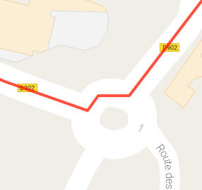  ⬅  ⬅  ⬅
17.5 | 0.5 | L | Stay on D902 = Rue des Boriots  Becomes Route de Galibier
18 | 17.6 | - | Col du Galibier begins. 17.6 km, 7% average, 1,200 m gain.
35.6 | 8.4 | - | Top of Galibier. There is a café at the top.  Continue on D902 through the tunnel – Gamin may tell you otherwise.
44 | 20 | R | D1091 = Le Lautaret. Towards Les Cours and Bourg d’Oisans
64 | 18.2 | Stay R | Stay on D1091 through tunnels
82.2 | 14 | 1st exit | D211  Alpe d’Huez begins.  14.3 km, 8% average,  1,097 m gain  Stay on D211 and follow Tour de France signs. | 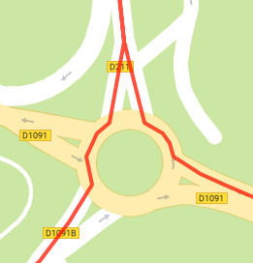  ⬅  ⬅  ⬅
96.2 | 0.2 | R | Avenue de l’Etendard.  Stay “straight” through first traffic circle to the second traffic circle. | 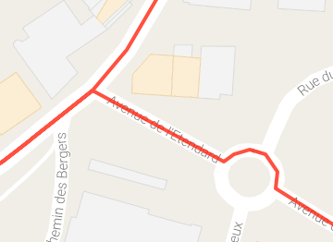  ⬅  ⬅  ⬅  ⬅

KM | KM TO  NEXT | TURN | ROAD AND COMMENTS
96.4 | 0.2 | 2nd exit | D211F | 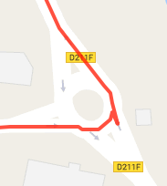  ⬅  ⬅  ⬅
96.6 | 0.1 | L | Rue du Pic Bayle | 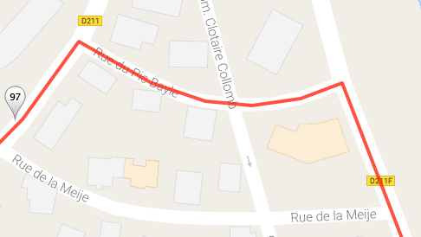  ⬅  ⬅  ⬅
96.7 | 14.6 | L | D11 = Route du Signal and head down the same way you came up Alp d’Huez
111.3 | 0.9 | 2nd exit | D1091B in to Bourg d’Oisans = Rue Aristide Briand | 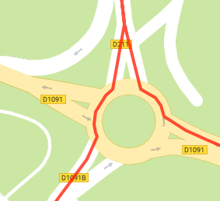  ⬅  ⬅  ⬅
112.2 | 0 | - | End at La Muzelle Restaurant  43 Avenue de la Republique

ADDITIONAL RESOURCES:
- Start: Saint Michel-de-Maurienne
- 17 km: Valloire
- 18 km: Col Collective Galibier
- 82 km: Col Collective Alps d’Huez
- End: Bourg d’Oisans

